SPH4U0 Data Analysis Quiz-#2 Name:________________________ Total: ____/28 marks [K/U]

1.Give the number of significant digits in each of the following measurements: [3]

1. 0.0350 s 52000 km= ____________ b) 5.260 x 103 m _______ c) 52000 km _________

2. You are testing a radioactive source using a Geiger counter. The source generates 55 counts in given time

interval. How many significant digits are there in this count? Explain your answer. [2]

3. Do the following calculations, rounding off answers to the appropriate number of significant digits. Include correct units in your answer. [3]

a) 27 m x 1.32 m= b) 1.245 s + 0.365 s + 1.7 s = c) 55.694 g/ 2.35 cm3 =

4. Perform the following units conversions, expressing your final answer in scientific notation if necessary.

Show your work. [6]

1. 0.00045 µm = ? pm b) 1890 cm3= ? m3 c) 85 km/h = ? m/s

5. a) Find the relative (percent) uncertainty in the following distance measurement. [1]

Δ d= 1.65 ± 0.08 m

1. Find the total length and the **absolute uncertainty**. Include the appropriate number of significant digits in your answer. [2]

LTotal = L1 + L2 – L3 L1= 2.4± 0.1 cm L2=58.9 ± 0.4 cm L3 = 6.3 ± 0.1 cm

1. Find the volume and the **absolute uncertainty**: Include the appropriate number of significant digits in your answer. [3]

Volume = length x width x height L= 13.4 ± 0.2 m W=4.60 ± 0.04 m H=9.65± 0.05 m

6. The table below shows the result of an experiment to investigate the variation of centripetal force (F) with frequency of rotation(f) when a ball at the end of a string is swung in a circle. Graph the relationship (Force versus Frequency) on the graph paper provided. [3]

|  |  |  |  |  |  |  |  |  |  |  |
| --- | --- | --- | --- | --- | --- | --- | --- | --- | --- | --- |
| Frequency (f)  (Hz) | 0.50 | 1.00 | 1.50 | 2.00 | 2.50 | 3.00 | 3.50 | 4.00 | 4.50 | 5.00 |
| Force (F) (N) | 0.16 | 0.63 | 1.41 | 2.50 | 3.95 | 5.65 | 7.70 | 10.00 | 12.75 | 15.70 |

1. 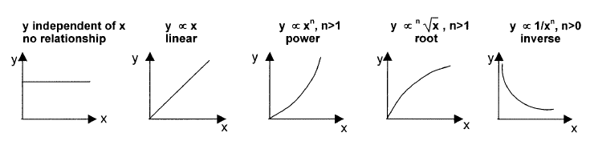Which of the following general relationships best describe this graph? Explain your choice. [2]
2. Describe the steps in the graphical analysis process you would use to determine the expression for the full mathematical relationship that describes this graph. [3]